DEX28-BRI2P R1A PCB CAM Files – Generated in Protel 99SE (DEX28-BRI2P R1A.PCB)

- Gerber and NC Drill files are given in inch units and in 2:4 formats.
- Gerber apertures are embedded.

4-Layer stack-up: 1.6mm with 35µm copper (all layers)

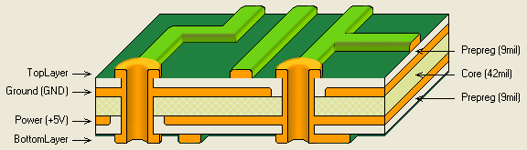
Example (with required values in red):
Quantity | Material | Type | Thickness (mm)
1 | Copper plating |  | 0.025
1 | Copper foil | 12 µm | 0.012 |  | Top Layer
2 | Prepreg | 2116 | 0.230
1 | Inner layers | 1.08mm 35/35 | 1.130* |  | Ground
 |  |  |  |  | Power
2 | Prepreg | 2116 | 0.230
1 | Copper foil | 12 µm | 0.012 |  | Bottom Layer
1 | Copper plating |  | 0.025
 |  | Total thickness: | 1.664

Gerber Files
DEX28-BRI2P R1A.GTO | Top Overlay
DEX28-BRI2P R1A.GBO | Bottom Overlay (not used)
DEX28-BRI2P R1A.GM1 | Non-plated Outer Contour (cutter diameter 2.4mm)
DEX28-BRI2P R1A.GTL | Top Layer
DEX28-BRI2P R1A.GP1 | Ground Plane
DEX28-BRI2P R1A.GP2 | Power Plane
DEX28-BRI2P R1A.GBL | Bottom Layer
DEX28-BRI2P R1A.GTS | Top Solder Mask
DEX28-BRI2P R1A.GBS | Bottom Solder Mask
DEX28-BRI2P R1A.GD1 | Drill Drawing
DEX28-BRI2P R1A.GG1 | Drill Guide
DEX28-BRI2P R1A.GTP | Pad Master, Top
DEX28-BRI2P R1A.GBP | Pad Master, Bottom (not used)

NC drill files
DEX28-BRI2P R1A.TXT | ASCII format drill file.
DEX28-BRI2P R1A.DRR | Drill report, detailing the tool assignments, the hole sizes, hole count and the tool travel.
DEX28-BRI2P R1A.DRL | Binary format drill file.

